Assignment 5

**Data Structures**

**CSCI-2720c**

Prepared By:

Anjiya Kazani, John Gunerli

20 November 2021

**Table 1:**

|  |  |  |  |
| --- | --- | --- | --- |
| **Algorithm Type** | **Input Type** | **Comparisons** | **Comments** |
| Selection sort | Ordered | 49995000 | The time complexity of an ordered selection sort is O(n2). Expect an output of 8-9 digits which aligns with the Big-O time complexity of this algorithm. |
| Selection sort | Random | 49995000 | The time complexity of a random selection sort is O(n2). Expect an output of 8-9 digits which aligns with the Big-O time complexity of this algorithm. |
| Selection sort | Reversed | 49995000 | The time complexity of a reversed selection sort is O(n2). Expect an output of 8-9 digits which aligns with the Big-O time complexity of this algorithm. |

|  |  |  |  |
| --- | --- | --- | --- |
| Merge sort | Ordered | 69008 | The complexity for an ordered Merge Sort is O(nlogn) for all input cases. Expect an output of 5-6 digits. This aligns with the Big-O time complexity. |
| Merge sort | Random | 120414 | The complexity for a random Merge Sort is O(nlogn) for all input cases. Expect an output of 5-6 digits. This aligns with the Big-O time complexity. |
| Merge sort | Reversed | 64608 | The complexity for anReversed Merge Sort is O(nlogn) for all input cases. Expect an output of 5-6 digits. This aligns with the Big-O time complexity. |

|  |  |  |  |
| --- | --- | --- | --- |
| Heap sort | Ordered | 259244 | The complexity for an ordered Heap Sort is O(nlogn) for all input cases. Expect an output of 5-6 digits. This aligns with the Big-O time complexity. |
| Heap sort | Random | 246954 | The complexity for a random Heap Sort is O(nlogn) for all input cases. Expect an output of 5-6 digits. This aligns with the Big-O time complexity. |
| Heap sort | Reversed | 235056 | The complexity for a reversed Heap Sort is O(nlogn) for all input cases. Expect an output of 5-6 digits. This aligns with the Big-O time complexity. |

|  |  |  |  |
| --- | --- | --- | --- |
| Quick -FP | Ordered | 50004999 | The complexity for an ordered Quick Sort-FP is O(n2) for all input cases. Expect an output of 8-9 digits. This aligns with the Big-O time complexity. |
| Quick -FP | Random | 159534 | The complexity for a random Quick Sort-FP is O(nlogn) for all input cases. Expect an output of 5-6 digits. This aligns with the Big-O time complexity. |
| Quick -FP | Reversed | 49999999 | The complexity for a reversed Quick Sort-FP is O(n2) for all input cases. Expect an output of 8-9 digits. This aligns with the Big-O time complexity. |

|  |  |  |  |
| --- | --- | --- | --- |
| Quick - RP | Ordered | 95535 | The complexity for a random Quick Sort-RP is O(nlogn) for all input cases. Expect an output of 5-6 digits. This aligns with the Big-O time complexity. |
| Quick - RP | Random | 80601 | The complexity for a random Quick Sort-RP is O(nlogn) for all input cases. Expect an output of 5-6 digits. This aligns with the Big-O time complexity. |
| Quick - RP | Reversed | 84706 | The complexity for a random Quick Sort-RP is O(nlogn) for all input cases. Expect an output of 5-6 digits. This aligns with the Big-O time complexity. |

**Table 1 Analysis:**

**a. Provide the total number of comparisons used by each one of the algorithms and explain whether they align with the Big O time complexity of each algorithm. In case of quick sort, compare and comment about the number of comparisons and complexity with the other quicksort implementations.**

* For O(nlogn) complexities we expect an outcome of 5-6 digits and an outcome of 8-9 digits with O(n2) complexities. This is because our size of input is 10,000 so for O(n2), n2 will be 100,000 and for O(nlogn), nlogn would be 40,000. As far as Quick sort is concerned, the complexity for FP and RP algorithms for all three input types were the same however, RP for all three was significantly faster and had lesser comparisons then that of Quick Sort FP. This is because Random Pivot minimizes the probability of bad splits.

**b. Did you use extra memory space or other data structures other than the input array? If so, explain where and why?**

* We have created temp auxiliary arrays to ensure the merging works properly. When we’re doing merge sort, it’s within requirement to use a temporary array in order to merge the arrays into each other. At Sorting::Merge we called in a temp array to ensure that merging it done correctly. This is the extra memory space that is allocated in order to perform the mergesort algorithm.

**c. Explain what sorting algorithms work best in what situations based on your experimental results.**

* MergeSort was the most efficient algorithm based on it’s performance on all cases because it had a complexity of O(nlogn). Even though HeapSort also had a complexity of O(nlogn) on all three input types, MergeSort had 5 digits comparisons for ordered and reversed types compared to that of HeapSort which were 6. Even though they both had 6 digits for random input type, MergeSort was still faster. Overall, MergeSort is the most efficient compared to other algorithms.

**Table 2:**

|  |  |  |  |  |  |  |  |  |
| --- | --- | --- | --- | --- | --- | --- | --- | --- |
| **Algorithm** | **10** | **100** | **500** | **1000** | **10,000** | **20,000** | **50,000** | **100,000** |
| **Selection** | 45 | 4950 | 124750 | 499500 | 49995000 | 199990000 | 1249975000 | 4999950000 |
| **Merge** | 22 | 545 | 3834 | 8675 | 120442 | 260897 | 718081 | 1536350 |
| **Heap** | 51 | 1159 | 7986 | 18059 | 246720 | 533565 | 1467092 | 3134862 |
| **QuickSort-fp** | 29 | 650 | 5486 | 10663 | 158019 | 364354 | 975656 | 2313451 |
| **QuickSort-rp** | 21 | 530 | 2656 | 6636 | 95413 | 200331 | 642316 | 1410873 |

**Worst Case Table:**

|  |  |  |  |  |  |  |  |  |
| --- | --- | --- | --- | --- | --- | --- | --- | --- |
| n^2 | 10 | 1000 | 25000 | 1000000 | 100000000 | 400,000,000 | 2500000000 | 10000000000 |
| Nlog(n) | 33 | 664 | 4482 | 9965 | 132877 | 285754 | 780482 | 1660964 |

***i. Selection Sort***

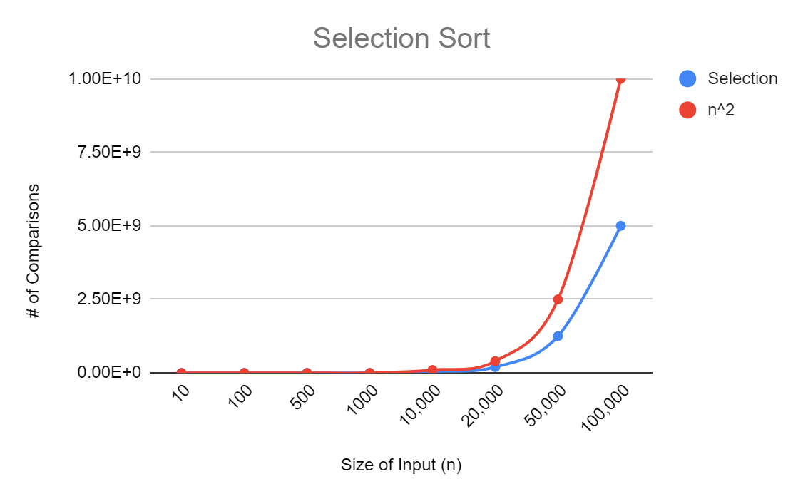

**Discussion:**

In the figure above, the red line represents the worst-case time complexity for Selection Sort which is O(n2). The blue line represents the results of our experiments with Selection sort. The results, theoretical and experimental, align for the Selection Sort algorithm. The experimental results follow closely with the worst case complexity and because the red line is the worst case, we expect our experimental lines average to be less than or equal to the O(n2) line. Selection sort had a complexity of O(n2) in all input cases. No inconsistencies were found in the graphing of Selection Sort.

***ii. Merge Sort***

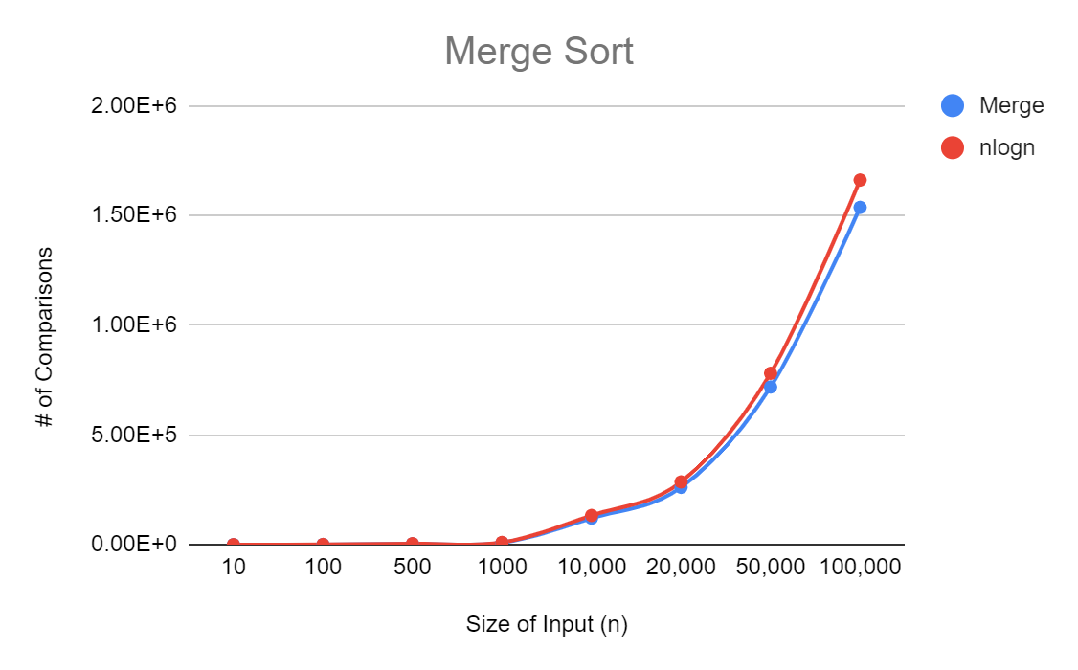

**Discussion:**

In the figure above, the red line represents the worst-case time complexity for Merge Sort which is O(nlogn). The blue line represents the results of our experiments with Merge sort. The results, theoretical and experimental, align for the Merge Sort algorithm and follow very closely with the nlogn curve. We expect our experimental lines average to be less than or equal to the O(nlogn) line; this proves that Merge sort has a complexity of O(nlogn) in all input cases and achieves its maximum efficiency with the 3 input types. No inconsistencies were found in this.

***iii. Heap Sort***

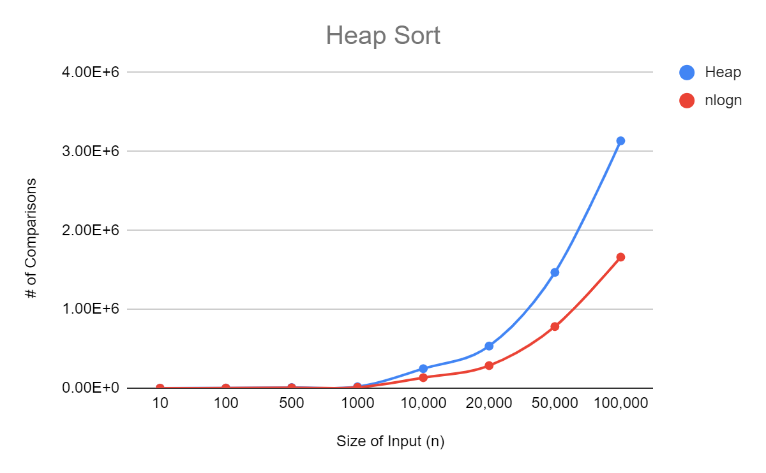

**Discussion:**

In the figure above, the red line represents the worst-case time complexity for Heap Sort which is O(nlogn). The blue line represents the results of our experiments with Heap sort. The results, theoretical and experimental, don’t fully align for our Merge Sort algorithm but still follows closely with the nlogn curve. We expect our experimental line’s average to be less than or equal to the O(nlogn) line; this graph however displays some inconsistencies because the Heap Sort line is above the worst case complexity. This is because in randomization there could be an issue in creating duplicate values and our Heap Sort algorithm doesn’t check for those.

***iv. Quick Sort-FP***

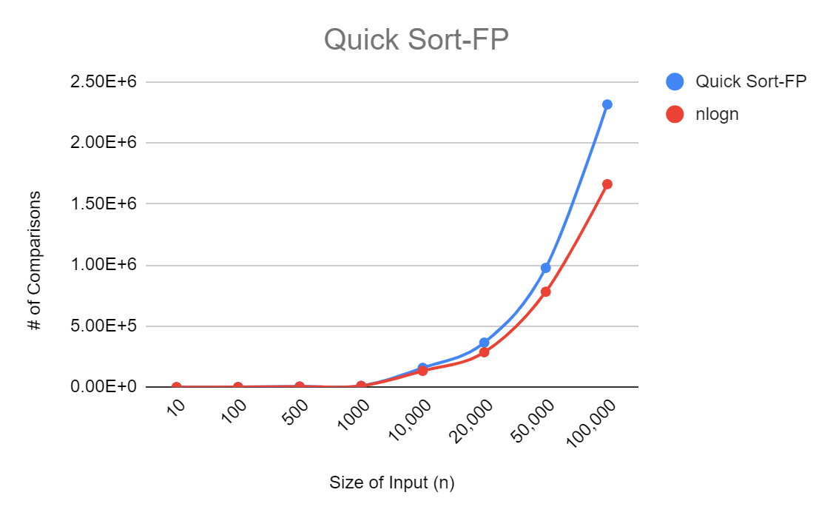

**Discussion:**

In the figure above, the red line represents the worst-case time complexity for Quicksort-FP which is O(nlogn) and the blue line represents the results of our experiments with QuickSort-FP. Even though the two lines are close in alignment, our QuickSort line is above the nlogn line which means our algorithm is slightly worse then the theoretical complexity therefore inconsistent. The reason for inconsistency could be because the first value could be smaller than the rest which would make partitioning into smaller arrays more difficult therefore this algorithm achieves maximum efficiency for random data only. When given ordered or reversed data, the algorithm has a O(n2) complexity making it less efficient. Overall, the experimental results coincide with the average Big-O complexity O(nlogn).

***v. Quick Sort-RP***

***Figure A (avg case) Figure A (worst case)***

**Discussion:**

In the figures above, the red line represents the average (nlogn) and worst (n2) time complexity for Quicksort-RP and the blue line represents the results of our experiments with QuickSort-RP. In Figure A, our algorithm proves to be more efficient than the worst case however in Figure B, our algorithm closely aligns with the O(nlogn) line. This is because in a random pivot, it ensures the possibility of getting the worst-case complexity is lower, making it closer to the nlogn line. Quick Sort - RP algorithm achieves maximum efficiency for random data only. When given ordered or reversed data, this algorithm is less efficient with a O(n^2) complexity. Overall, the experimental results coincide with the average Big-O complexity O(nlogn).